General Chemistry 2 | 3rd Quarter
MPT2: Concentration
January 19 2021
Virtual Lab Link
Virtual Lab Guide

Guide Questions:

- What solution concentration is used in the Virtual Lab in computing for the concentration of a solution, MOLARITY, MOLALITY, or PERCENTAGE CONCENTRATION BY MASS? What made you say so?

Molarity, because of the unit it displays which is mol/L.

- What is the concentration of pure water in the Virtual Lab?

0.00 mol/L.
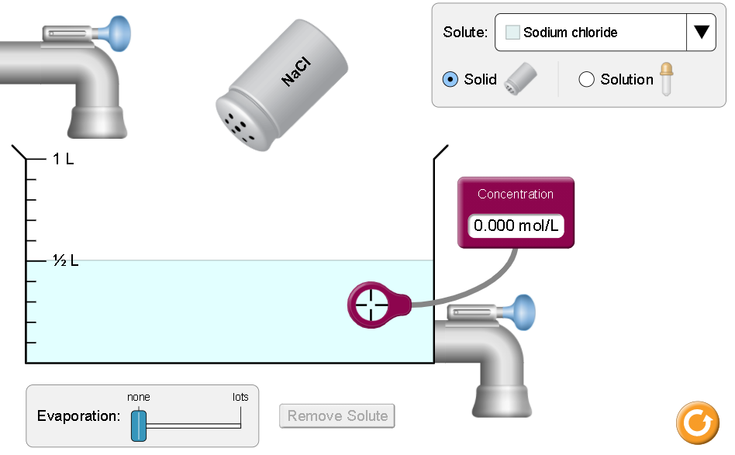

- If you double the amount of solvent (pure water), what will happen to the concentration of solid nickel (II) chloride? Solid copper (II) sulfate?

For NiCl₂, the solution became less concentrated significantly. While for the CuSO₄, the concentration didn’t decrease significantly.
NiCl₂ | CuSO₄
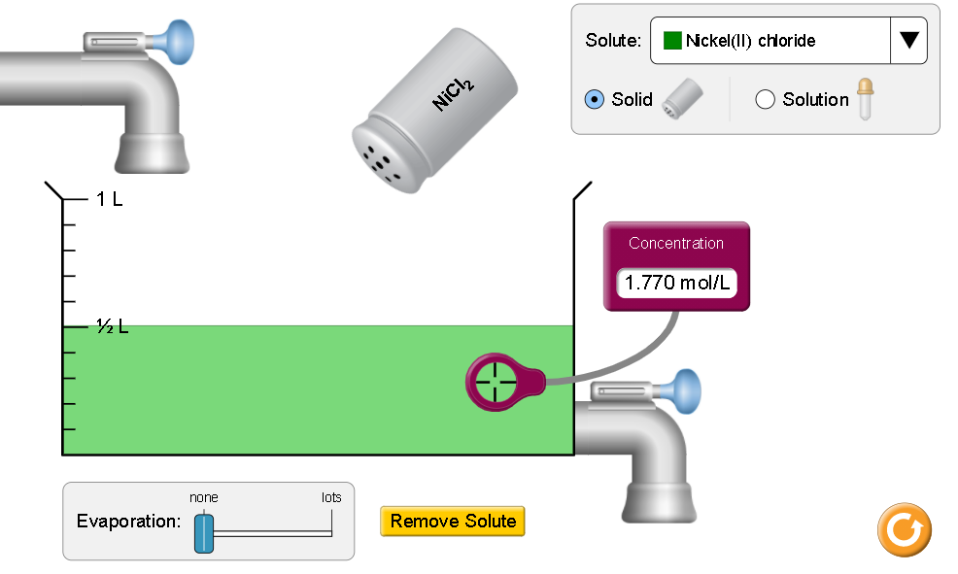 | 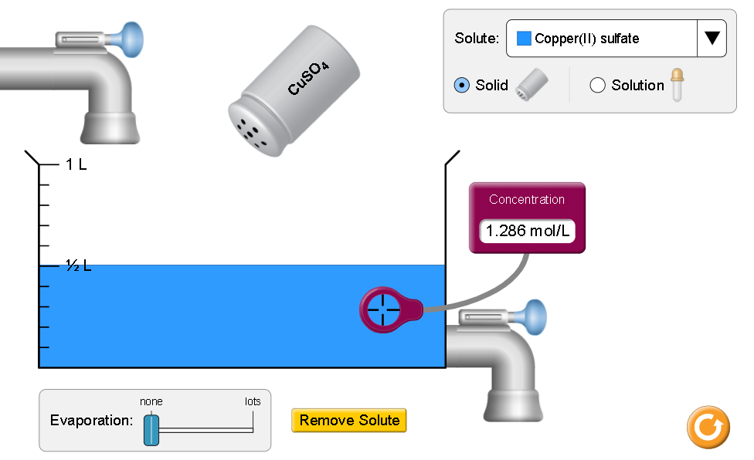
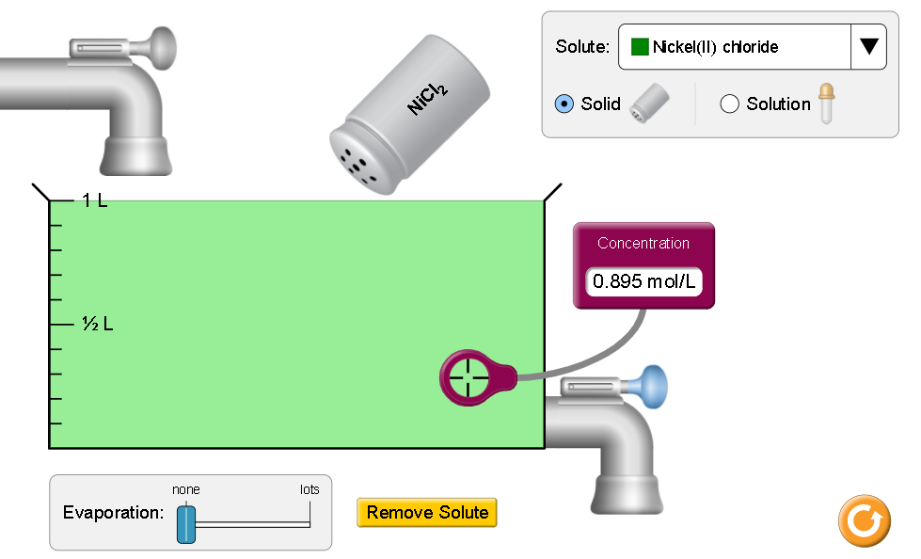 | 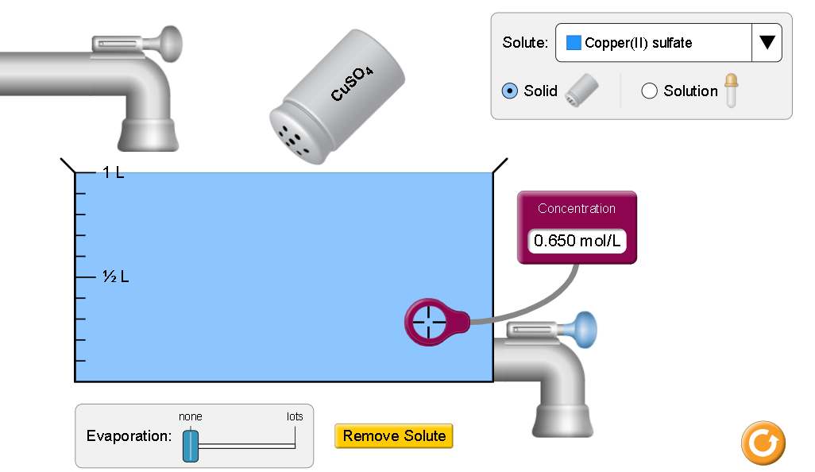

- For the same amount of solvent, what will happen to the concentration of the solution if you continue adding a solute for the same temperature?

If you continue adding a solute, the concentration will drastically go up.

- Cite 2-3 steps you did to increase the concentration of the solution.

  - Add more solute to the solution.
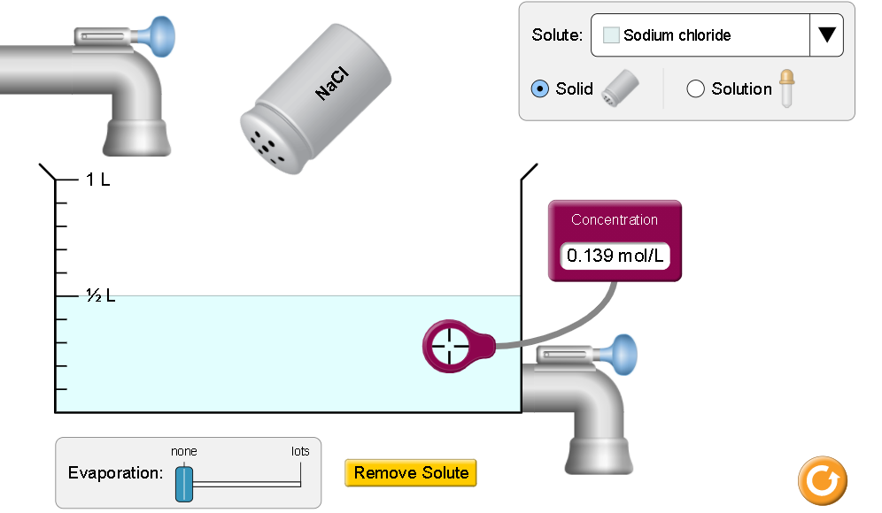 | 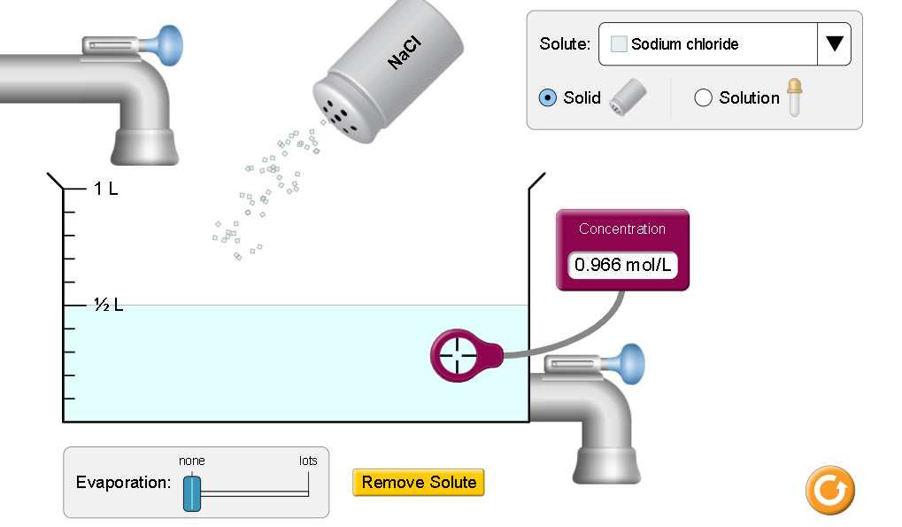

  - Evaporate the solution.
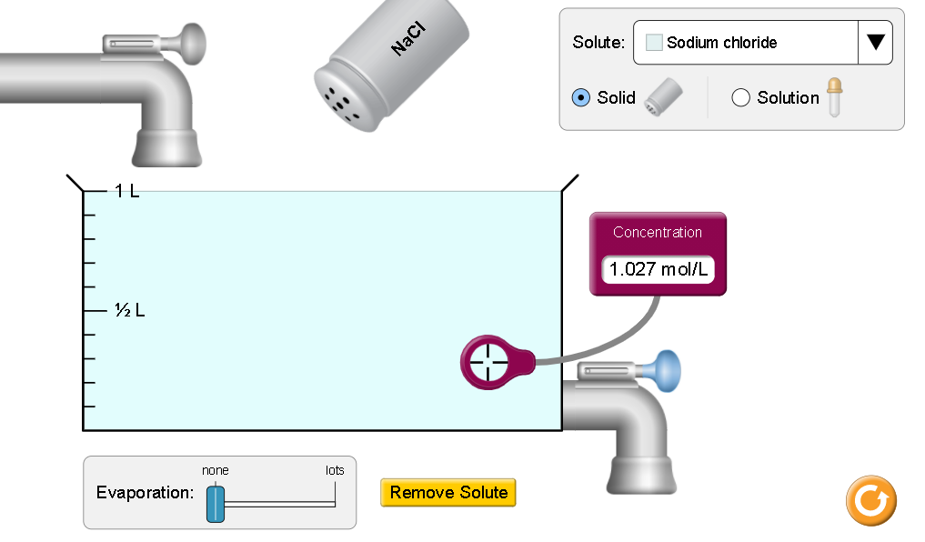 | 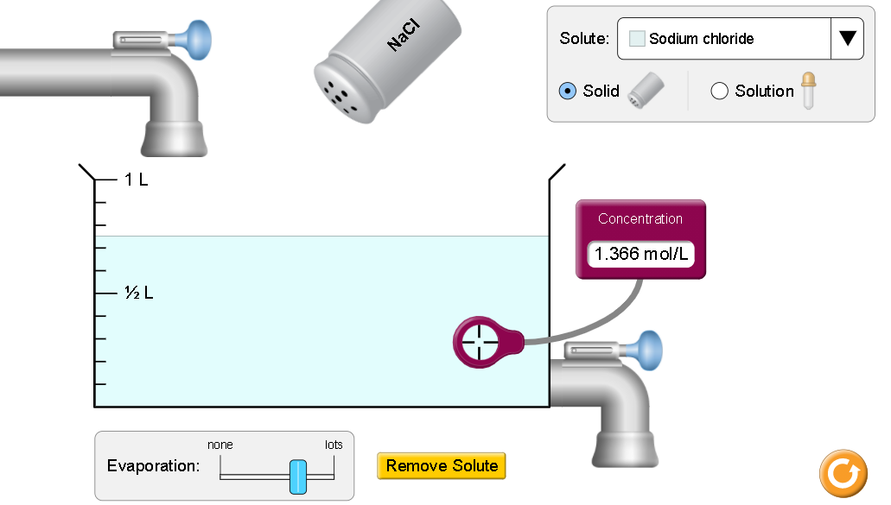

  - Drop liquid solute in it.
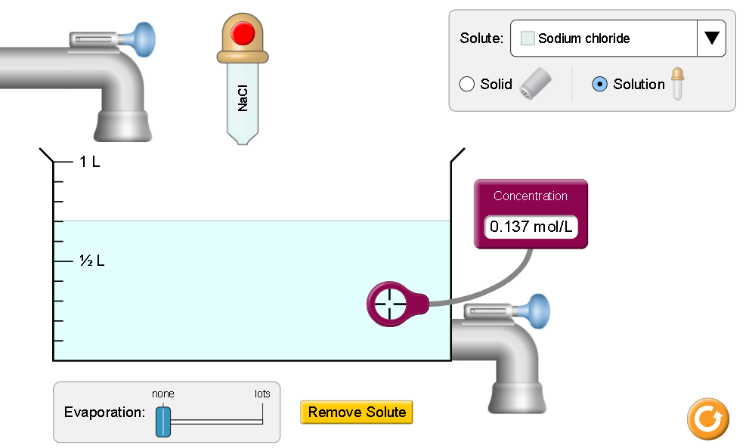 | 